WWW.FSRTEK.COM

鞋垫压力传感器
Model：Insole FSR-12
类型：矩阵式

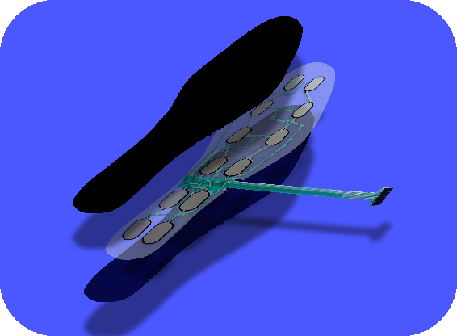

Nanjing Momao Electronic Technology Co.,Ltd
Add: Room 207,Building 3,Tongxinyuan technology innovation center,
No.402, Yinfu street,Jiangning District,Nanjing,China
Tel：+86 25-52104047

WWW.FSRTEK.COM

Description/描述 ：
This type of product is used in the insole, to measure the pressure distribution and dynamic changes of on the insole. This product has a total of 12 sensing points, evenly distributed in the contact position between the foot and the insole, can collect the force applied positions and pressure changes information when user walking, running, jumping.
本型号产品是用于鞋垫中，测量足底压力分布及动态变化的压力传感器。本产品共计有12个感应点，均匀分布于脚掌和鞋垫的接触位置，可以采集正常行走，跑步，跳跃过程中的不同发力点位置和压力大小变化。

Features and Benefits/优点 ：
• Sensitive response - minimum trigger force at each sensor point is 50g
反应灵敏-每个感应点最低触发力为50g
• Large force range - each insole can withstand more than 100KG of pressure
大量程-每只鞋垫可以承受100KG以上的压力
• Ultra thin -the sensor total thickness is about 0.3mm
超薄-传感器厚度约为0.3mm
• Convenient data acquisition - using matrix circuit design, easy to collect pressure distribution and change data
方便数据采集-采用矩阵式电路设计，方便采集压力分布和变化数据
• Convenient installation and integration - our company can provide data acquisition and transmission module, you can easily complete the installation of the collector
方便安装集成-我公司可提供数据采集和传输模块，可以轻松完成采集器的安装
• Low Cost - This sensor offers a low cost advantage over other forms of sensors, especially for multi-point distributed acquisition pressure applications.
成本低廉-相对于其他形式的传感器，特别在实现多点分布采集压力的用途上，本传感器有很好的低成本优势。

Photo/产品照片：
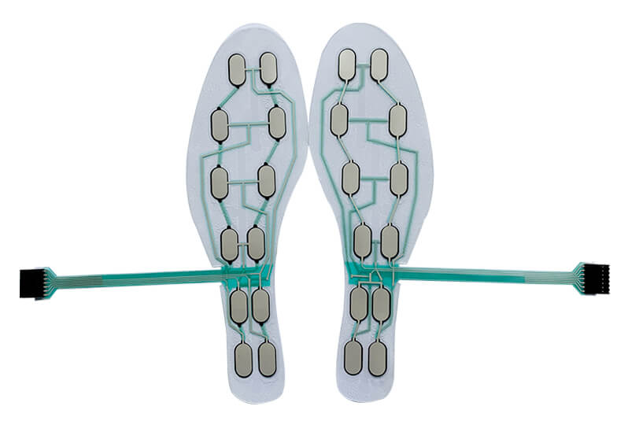

WWW.FSRTEK.COM

Size/尺寸 :
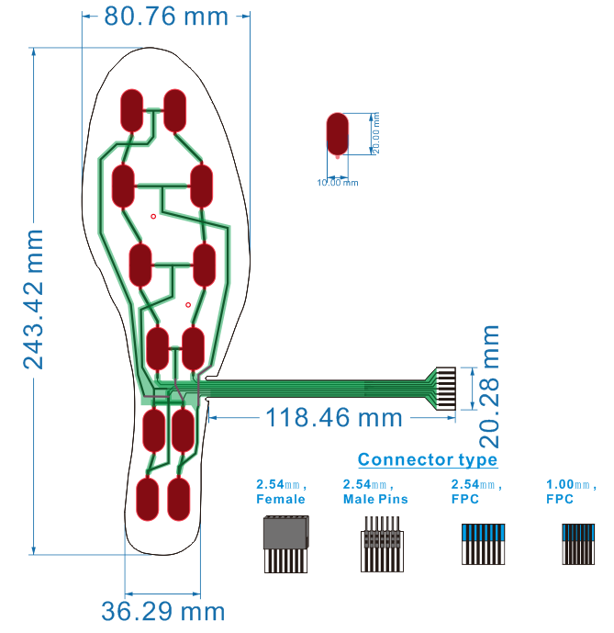
Structure /结构:
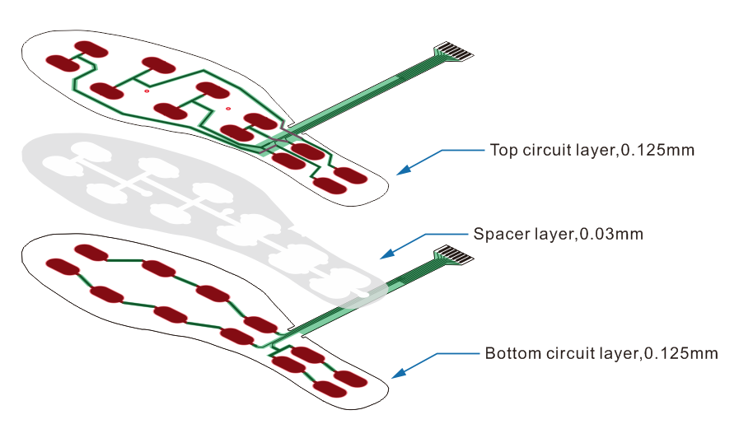
隔层，0.03mm
下电路，0.125mm
上电路，0.125mm

Specification：
Item/项目 | Data/数据
Sensor size(single point sensor)/单感应点尺寸 | 20.5*11mm
Sensor quantity/感应点数量 | 12
Force measure range(single point sensor)/单感应点量程 | 50G ~ 20KG
Force measure range(1 piece insole sensor)/正片传感器量程 | 10KG~100KG
FSR Thickness/传感器厚度 | <0.3mm
Force repeatable （part to part）/不同感应点的重复性 | ±10%
Off resistance/无压力时电阻 | >2 MΩ
Force resolution/力测量方式 | Continuous（连续测量）
Response time/反应时间 | <1 ms
Operating temperature/工作温度 | -20℃~60℃
Life time/使用寿命 | > 2 million /200万次
Connector/连接器型号 | Female 2.54mm / Male pins 2.54 / FPC 2.54 or 1.0mm
Application Information/使用说明：
The Foot Pressure Sensor is a matrix pressure sensor that can be interpreted as a 3 row by 4 column matrix circuit design with a total of 12 sensor points . There are two circuits layer on the structure, the upper circuit layer connector has 3PINs, the lower circuit layer connector has 4PINs.
Usually when integrate the insole to PCB, the three PINs of the upper circuit can be connected to the channel switch chip, an RM is connected in series on each PIN, and connect to GND. The four pins of the lower circuit are connected to the ADC1~4 (as shown in the figure below). At the beginning of the operation, the switch channel chip will turn on the power channel CH1~CH3 in turn, and the MCU will collect the voltage on ADC1~ADC4 in turn, By compare and calculate the data from ADC, and obtain the distribution information of the pressure weight at all the sensor points.
Tips:The order of collecting voltage is as followed.CH1 is open(at same time CH2&3 are closed),MCU collect the voltage from ADC1 to ADC4,these voltages are form Sensor point 1~4#,then close CH1 and open CH2,MCU collect the voltage from ADC1 to ADC4,these voltages are form Sensor point 5~8#,then close CH2 and open CH3,MCU collect the voltage from ADC1 to ADC4,these voltages are form Sensor point 9~12#.

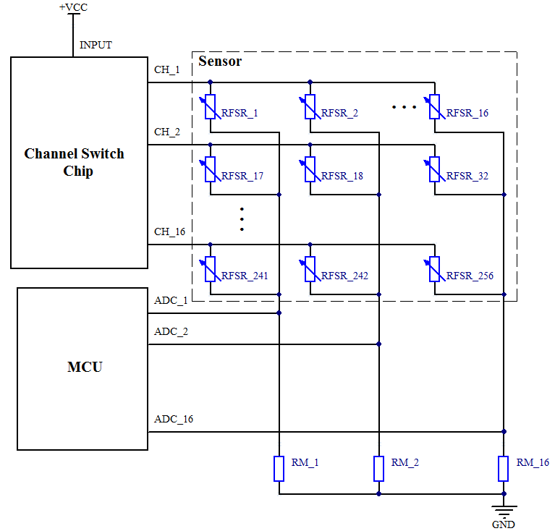
这款足底压力传感器是矩阵式压力传感器，可以理解为3行*4列的矩阵线路设计，共计有12个点。结构上有上下两层电路，上电路接头有3PINs,下电路接头有4PINs.
通常连接鞋垫压力传感器时可以将上电路3个PIN连接到通道开关芯片，并且在每一个PIN的连接上串联一个RM，并且接地。将下电路的4个PIN分别连到ADC1~4采集器上（如下图）。开始工作时，开关通道芯片依次循环的打开电源通道CH1~CH3，MCU依次采集ADC1~ADC4上的电压，并且将数据进行比较和计算，获得在所有感应点上压力轻重的分布信息。

Nanjing Momao Electronic Technology Co.,Ltd
Add: Room 207,Building 3,Tongxinyuan technology innovation center,
No.402, Yinfu street,Jiangning District,Nanjing,China
Tel：+86 25-52104047

