WWW.FSRTEK.COM

Matrix force sensor data sheet

Model：FE273
60Row &60 Coulunm
3400 Sensor points

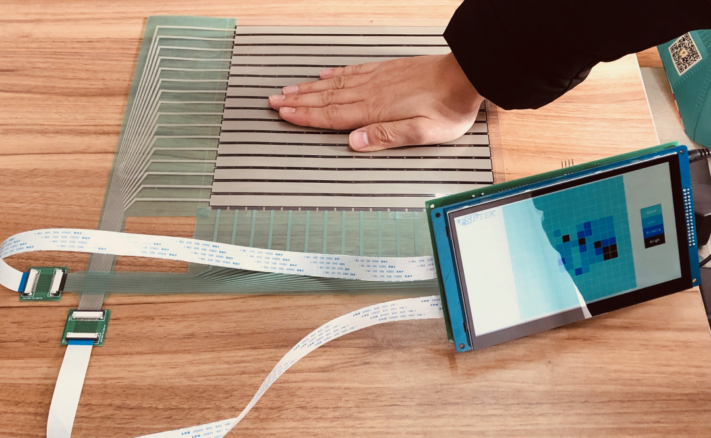

Nanjing Momao Electronic Technology Co.,Ltd
Add: Room 207,Building 3,Tongxinyuan technology innovation center,
No.402, Yinfu street,Jiangning District,Nanjing,China
Tel：+86 25-52104047

WWW.FSRTEK.COM

Description ：
Matrix FSR circuits are usually composed of rows and columns intersecting.As this FSR, 60 circuit trace and 60 columns of circuit trace can form 3600 intersection points, and each intersection point is a sensor point. In this way, a pressure distribution map covering 3600 sensor points can be made.The 60 rows and 60 columns of circuit trace converge at the cable tail and connect to a 120 Pins connector.When the pressure is applied to the sensor area containing 3600 sensor points, the force on each sensor point may be different, so the corresponding output voltage will be different.According to the characteristics of FSR, the sensor point applied with a larger force has a lower resistance and the output voltage is higher, and vice versa.By collecting the output voltage data through different sensor points and comparing them, the data collector can calculate where the points is under force and the distribution of the force. This is why we usually call this kind of sensor as a pressure map.

Features and Benefits ：
• Actuation force as low as 200g and sensitivity range to 100kg
• Ultra thin
• It is very convenient to collect the data of distribution area of force and relative value.
• Simple and easy to integrate
• Cost effective

Photo：
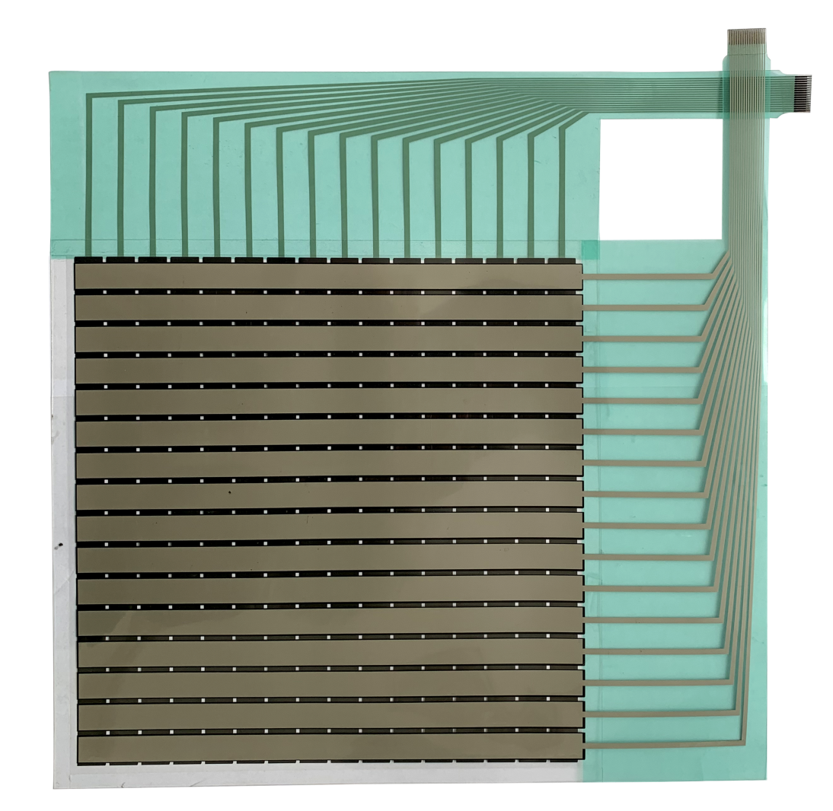

WWW.FSRTEK.COM

Size :
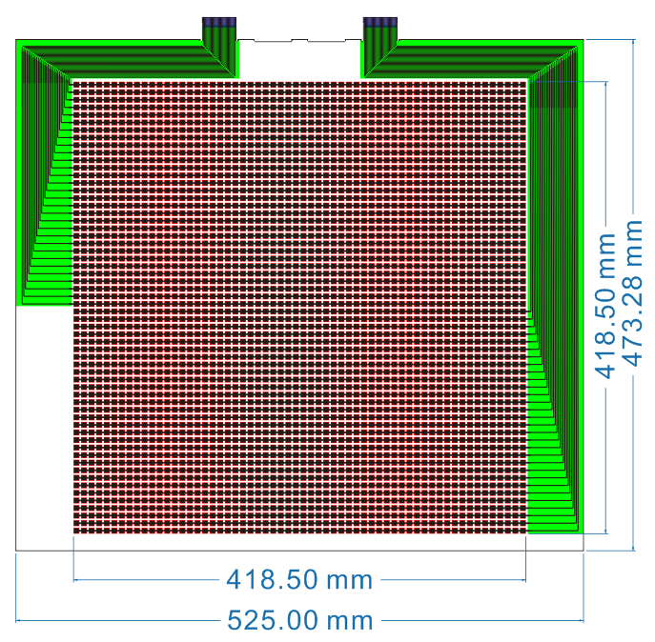

Connector:FPC 1.0mm
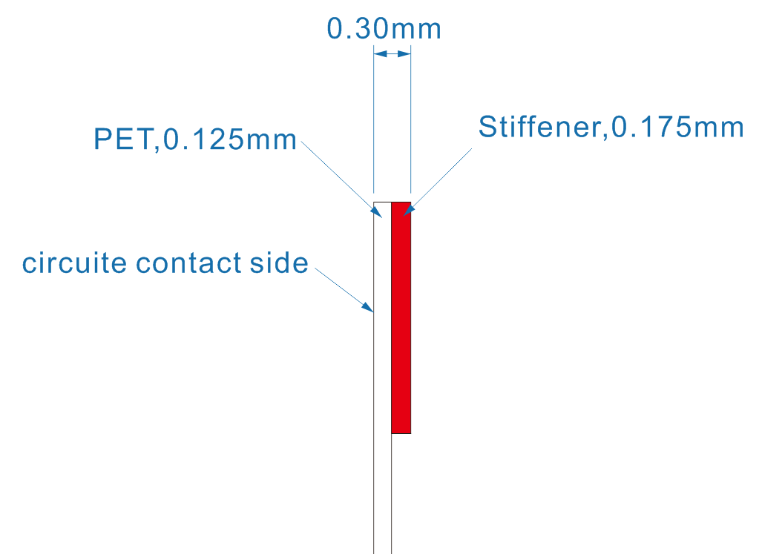
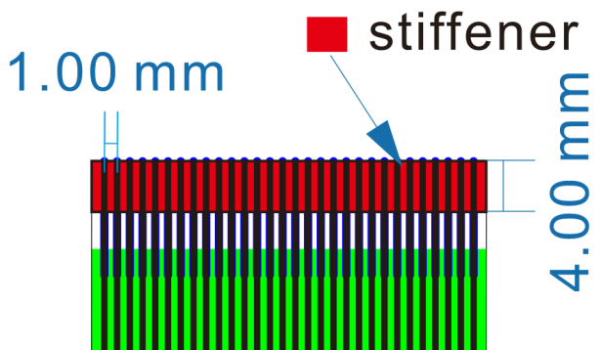

WWWFSRTEK.COM

Structure :

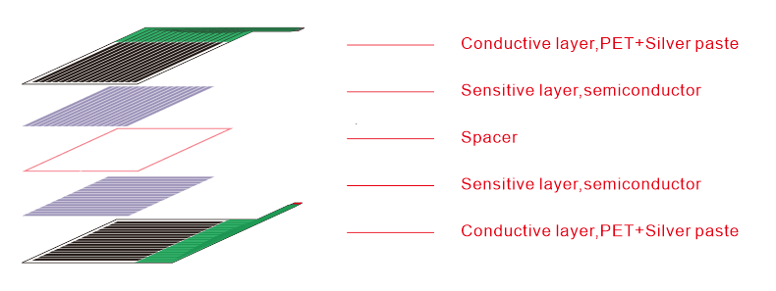

Specification：
Item | Data
Sensing Area | 418.5*418.5 mm
Force measure range | 200G ~ 100KG
Thickness | <0.3mm
Force repeatable （part to part） | ±20%
Off resistance | >2 MΩ
Force resolution | Continuous
Response time | <5ms
Operating temperature | -20℃~80℃
Life time | > 2 million
Connector | ZIF 1.0mm
Application Information：
This sensor is distributed in 60 rows and 60 arrays, with a total of 3600 pressure collection points.The reserved interfaces are two 60 Pins FPC connector (FPC_1 & FPC_2) spaced 1.0mm apart.Following figure is sample scheme for reference . Users can adjust the scheme according to the actual usage.
Example presentation:
FSR connector “FPC_1” is connected to ch_1 to 60 of the channel switch chip, FSR connector “FPC_2” is connected to rm_1-60 (the selection of RM resistance value can be determined according to the actual use of customer.Voltage on partial resistance (RM) end is measured through 60 ADC channels of the MCU.When start to test all the channel switch are closed, and then open the channel 1(CH_1), MCU collects the voltage value of ADC_1 to 60 , pressure value of RFSR_1 to 60(which are the first row RFSR) can be obtained by formula calculation.Then close CH_1 and open CH_2,MCU collect ADC_1 to 60 again,then obtain the force value of 2nd row RFSR(60-120). Continue in this way,the ch_1-60 channel switching chip and the ADC channel switching MCU can complete the overall scanning of 3200 pressure collection points.At last ,surface force on pressure sensor can be obtained through data analysis.
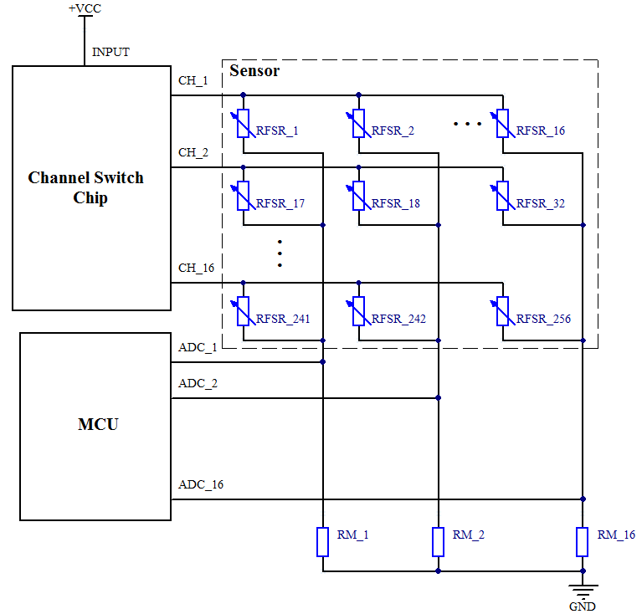
The display also can show which areas of the sensor are being applied and which are not.Further you can see which parts of the area applied have a larger force, which parts have a medium force, and which parts have a smaller force. For the movement and changing of force, the sensor is very sensitive.

Nanjing Momao Electronic Technology Co.,Ltd
Add: Room 207,Building 3,Tongxinyuan technology innovation center,
No.402, Yinfu street,Jiangning District,Nanjing,China
Tel：+86 25-52104047

